Describe the construction and operation of the following electrochemical cells:
a) the dry cell, primary cell
b) the lead-acid accumulator, secondary cell
c) the fuel cell e.g. hydrogen/oxygen fuel cell.

Name | Lechlanche or Dry Cell | Lead - Acid Accumulator Battery | Hydrogen/Oxygen Fuel Cell
 | 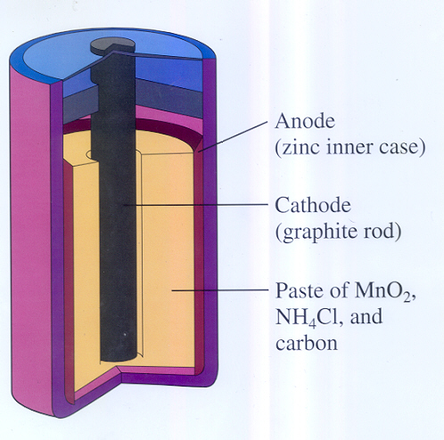 | 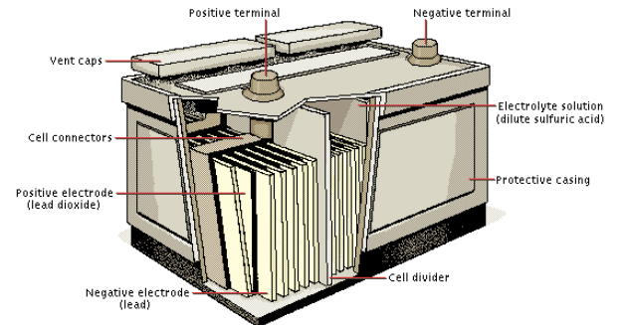 | 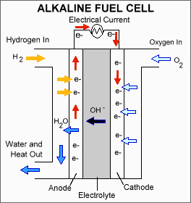
Cathode | Graphite (C) | Lead oxide (PbO₂) | Oxygen gas (O₂)
Anode | Zinc (Zn) | Lead (Pb) | Hydrogen gas (H₂)
Electrolyte | Manganese dioxide  Ammonoium chloride | Sulfuric acid (4.5 molL⁻¹ H₂SO₄) | Acid (H₃PO₄)  Alkaline (KOH)
Oxidation ½ equation | Zn_{(s)} → Zn²⁺_{(aq)} + 2e⁻ | Pb_{(s)} + SO₄²⁻_{(aq)} → PbSO_{4(s)} + 2e⁻ | H_{2(g)} → 2H⁺_{(aq)} + 2e⁻  2OH⁻_{(aq)}+H_{2(g)} →2H₂O_{(l)} + 2e⁻
Reduction ½ equation | 2MnO_{2(s)} + 2H⁺_{(aq)} + 2e⁻ → Mn₂O_{3(s)} + H₂O_{(l)} | PbO_{2(s)} + 4H⁺_{(aq)} + SO₄²⁻_{(aq)} + 2e⁻ → PbSO_{4 (s)} + 2H₂O_{(l)} | O_{2(g)} + 4H⁺_{(aq)} + 4e⁻ → 2H₂O_{(l)}  O_{2(g)} + 2H₂O_{(l)} + 4e⁻→ 4OH⁻_{(aq)}
Full RedOx equation | 2MnO_{2(s)} + 2H⁺_{(aq)} + Zn → Zn²⁺_{(aq)} + Mn₂O_{3(s)} + H₂O_{(l)} | Discharging (e.g. starting car, leaving car lights on) Galvanic  Pb_{(s)} + PbO_{2(s)} + 4H⁺_{(aq)} + 2SO₄²⁻_{(aq)} → 2PbSO_{4 (s)} + 2H₂O_{(l)} | 2H_{2(g)} + O_{2(g)} → 2H₂O_{(l)}
Recharging (when car engine is running) Electolytic
2PbSO_{4 (s)} + 2H₂O_{(l)} → Pb_{(s)} + PbO_{2(s)} + 4H⁺_{(aq)} + 2SO₄²⁻_{(aq)}
Cell Voltage  (emf) | 1.48 V | 2.05 V per individual cell, 12 V when 6 cells connected in series. | 1.23 V – only a theoretical value
Advantages | Low cost, raw materials readily available  Can be adapted to various shapes/designs  Can be connected in series to provide greater voltages/current | Relatively low cost.  Raw materials readily available  Secondary cell i.e. it can be recharged, lasts approx. 5 years.  Can be connected in series to provide greater voltages/current | Small mass  High fuel efficiency  Are direct energy converters, water is the resultant product
Disadvantage | Low voltage/current provided  Primary cell i.e. not rechargeable  Limited working life | Lead is a heavy metal poison  Rather heavy due to the high density of lead. Sulfuric acid to dispose of. | Small mass, need constant input of reactants.
Common Uses | Torches  Calculators  Smoke detectors  TV Remote controls | Primarily used in cars – to start the car, operate lights etc.  Electric fences on a farm.  Some electric powered vehicles. | Spacecraft – used as a source of electrical energy and water for astronauts

